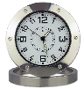 Digital Video Recording Desktop Alarm Clock

Please Note: When this guide refers to the lights on the clock, there are 2 LEDS inside the clock underneath the number “6”. You may need to alter your viewing angle in order to see them both.

Introduction:

These instructions will show you how to use the product. It provides the necessary information related to the product such as operating and handling instructions. It is recommended that you read the instructions fully and carefully before operation. Please keep the instructions safe for future reference!

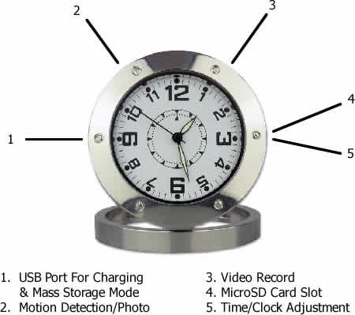 | - This port is used for charging the camera using the included USB charging cable or for connecting to a PC in order to access the inserted micro SD Memory Card  - This button activates Motion Detection Mode or takes a Photograph  - This button turns the camera On / Off and activates the standard video recording mode.  - This card slot is Micro SD size and will take up to a 32GB micro SD/Micro SDHC card.  - This dial allows you to change the displayed time on the physical clock face.

Usage Instructions:

IMPORTANT: You must insert a micro SD or Micro SDHC memory card with free space before using this device

Charging the Camera
Connect the clock via the included USB cable to either a free USB port on a desktop/laptop computer or a USB mains charger to begin charging. Whilst on charge the RED light (underneath “6”) will flash slowly. When fully charged the RED light will stop flashing and stay on.

Reading the micro SD or Micro SDHC Card
Connect the clock via the included USB cable to a free USB port on your desktop or laptop computer. You may see a message in the system tray about “Installing Device Drivers”. You will then see an “Auto play” window open which will allow you to access the inserted memory card. If the auto play window does not open it may be due to your settings. You can still access the memory card by going to “My Computer” and then double clicking the appropriate removable device.
If you are unsure which device is your card then do the following. Open the “My Computer” window and observe the contents. Plug in the clock and you will see the Removable Device appear in the window. Please allow up to 30 seconds for the device to appear.

Setting the Time on the Physical Clock
Pull out the dial (#5 on the illustration above) and rotate it to change the time on the clock. Whilst the dial is pulled out the clock will stop ticking. Push the dial back when you’re finished and the clock will resume.
Inserting the Micro SD Memory Card
To insert a memory card into the device, first observe the card slot on the side of the clock, see #5 in the illustration above. With the card contacts facing you (see below) insert the memory card and push until it clicks into place.
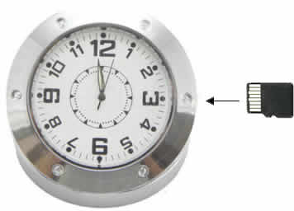
Illustration of Micro SD/Micro SDHC Orientation

Operating Instructions – Basic Operation

To Turn the Camera On: press and hold button #3. Almost immediately the BLUE light will come on, followed by the RED light. After a further 1 to 2 seconds the RED light will go out, leaving just the BLUE on solid. You can now let go of the button. The camera is now in standby mode (solid BLUE light).

To Turn the Camera Off: press and hold button #3. After 1 second the BLUE & RED lights will both flash 3 times and go out altogether. There will be NO lights on anymore. You can now let go of the button. The camera will also turn itself off from Standby mode ONLY if left untouched for approx. 30 seconds.

To Start Recording a Video
Press (click) button #3 to start video recording. The BLUE light will flash 6 times and then go out. The camera is now recording video.

To Stop Recording a Video
Press (click) button #3 to stop recording. The BLUE light will come back on solid to indicate the device is back in standby mode.

To Take a Photo/Snapshot
Press (click) button #2 to take a snapshot/photo. The BLUE light will go out and then come back on solid.

To Start Motion Activated Recording
Press and hold button #2 to begin motion detection recording. The BLUE light will flash 6 times and then go out. Please note: There is no indication that the clock is searching for motion or recording. There is also no indication of the transition between detection and recording.

To Stop Motion Activated Recording
Press (click) #3 to turn of motion detection recording. The BLUE light will come back on solid to indicate that the camera is in standby mode.

Videos are recorded in 5 minute clips, and will continue to record further clips when motion occurs.

Timestamp Edit
You may need to update the internal clock for the timestamp shown in images and videos.
To do this, you will need to create a Text file with the date and time.
- Plug the watch into your computer by using a USB cable.
- It will appear as a Removable Disk.
- Open the Removable Disk; you might have some folders and a text file called “time” already there.
- If you already have the text file then move onto Step 7.
- Right click in the white space and a menu will appear (Figure 3), move down to “New” and select “Text Document”.

Figure 2
- A new Text document will appear (Figure 4) and give you the option to name it, call it “time”.
Figure 3
- Open this time file and write the date and time in the following method:
2012-05-19 09:46:11
- Save and close the file.
- Unplug the watch from the computer and turn it on. The time is now updated.
Plug the watch back into your computer and delete the text file if still there.

